# Painting

Contents

Painting 1

• Water color paintings 1

• Oil paintings 1

• Acrylic paintings 1

• Charcoal drawings 2

• Abstract art 2

• Collage art 2

Painting is a creative process through which artists express their ideas, expressions by using different colors, composition, and texture. Painting is a visual art form where colors and other materials are typically applied to a surface using brushes, knives, sponges, hands and fingers. The surface can be canvas, paper, wall, wood, and metals.

Painting has a long history dating back thousands of years. When there was no script, people used to express themselves by using different art forms. Archaeologists found out many ancient cave paintings, Egyptian tombs, Greek and Roman art, through which they came to know about many facts regarding earlier life style.

Throughout history, painting has evolved from using hands to digital technologies. However, painting remains as the fundamental aspect of human creativity serving as a powerful tool for means of communication, imagination and interpretation of the world around us.

There are different types of paintings:

* 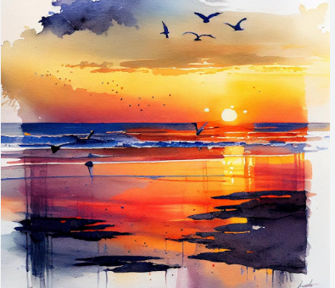Water color paintings: Artists use white of the paper to create art. Control and timing are essential as the medium requires quick decision making because of its unpredictable nature.
* 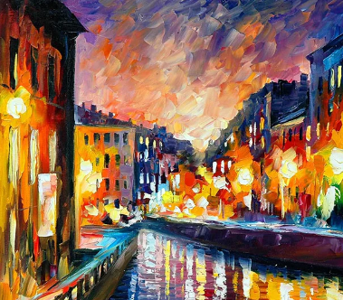Oil paintings: Artists use oil-based paints on canvas to create stunning, lifelike images. We can make realistic portraits to abstract expressions of creativity.
* 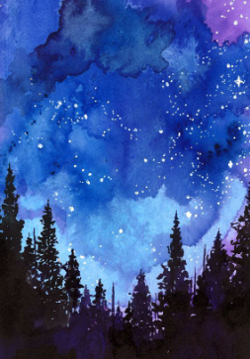Acrylic paintings: Artists can create texture and depth in acrylic paintings. These paints dry quickly, so artists can add layers and work efficiently making ideal choice for artwork.
* 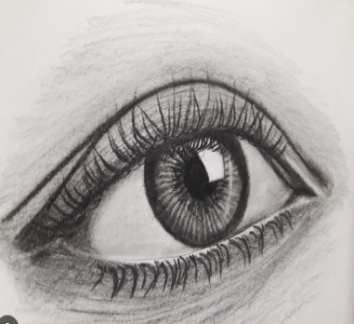Charcoal drawings: Artists use charcoal to create detailed portraits, highlighting subject’s character and depth. It captures emotions in detailed way.
* 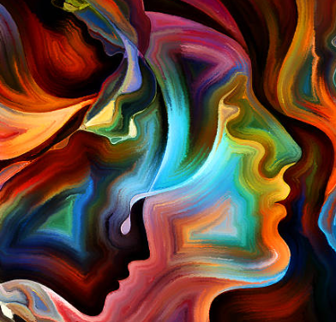Abstract art: Abstract paintings are non representational forms. They often evoke emotions or ideas rather than depicting specific objects. By observing these paintings, viewers interpret artwork in their own unique way. It creates individual experiences. It can be deeply personal and thought provoking experience for both artists and art enthusiasts.
* 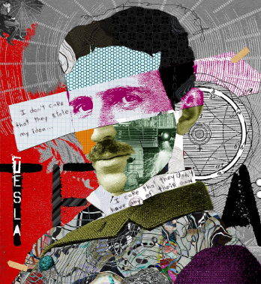 Collage art: Modern collage art explores abstract themes, combining diverse elements to create thought provoking compositions.